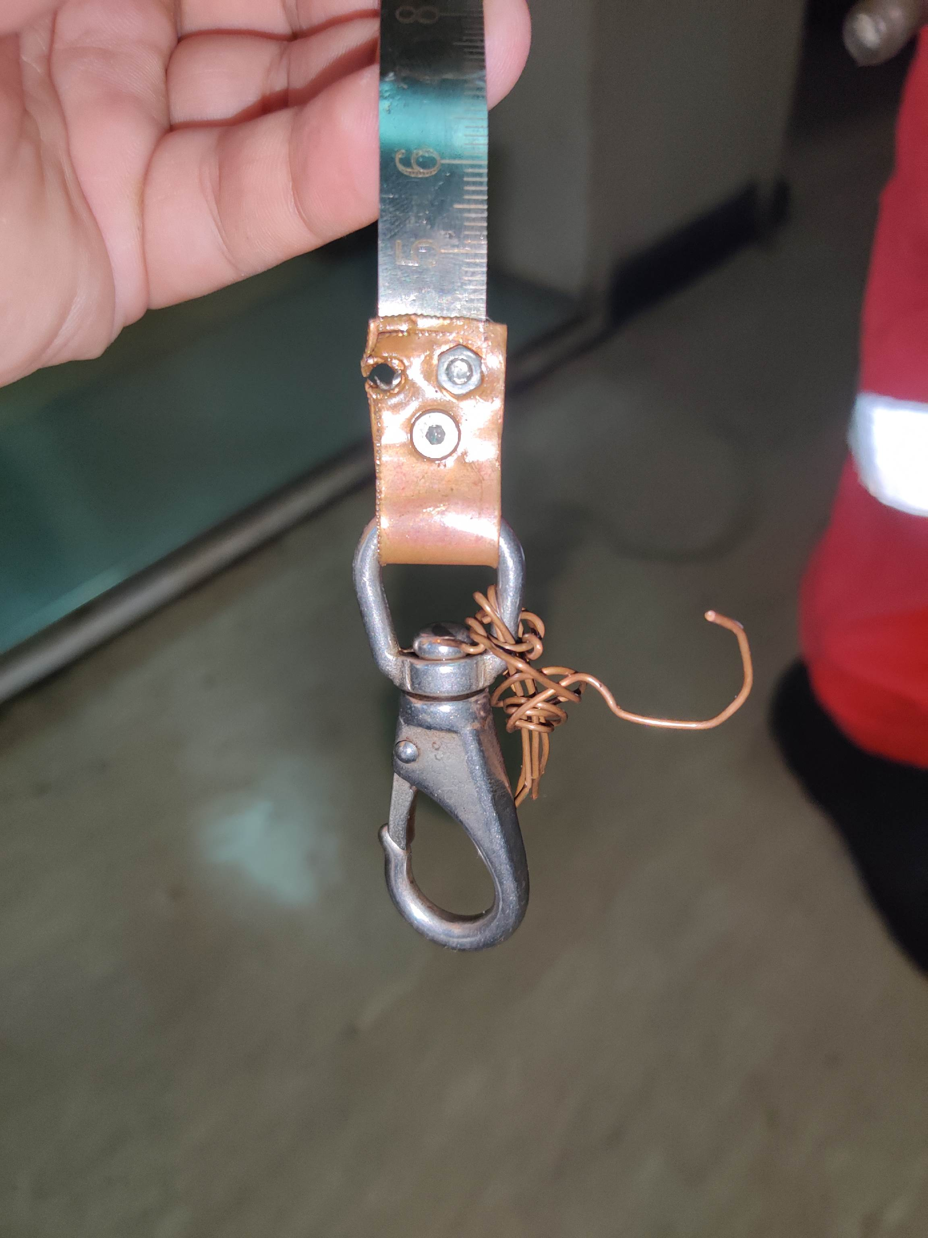
TEMP MODIFICATION WITH REDUCED TAPE LENGTH
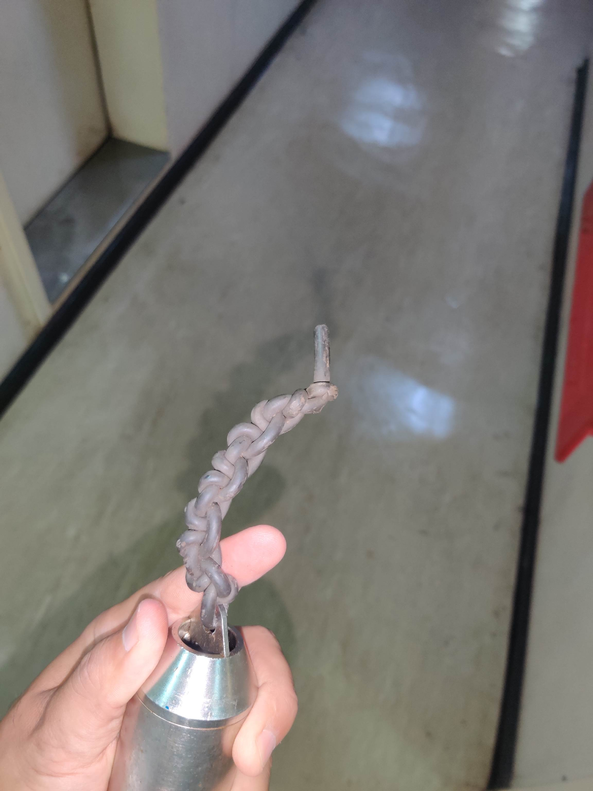
CONNECTING ROPE IS DAMAGED
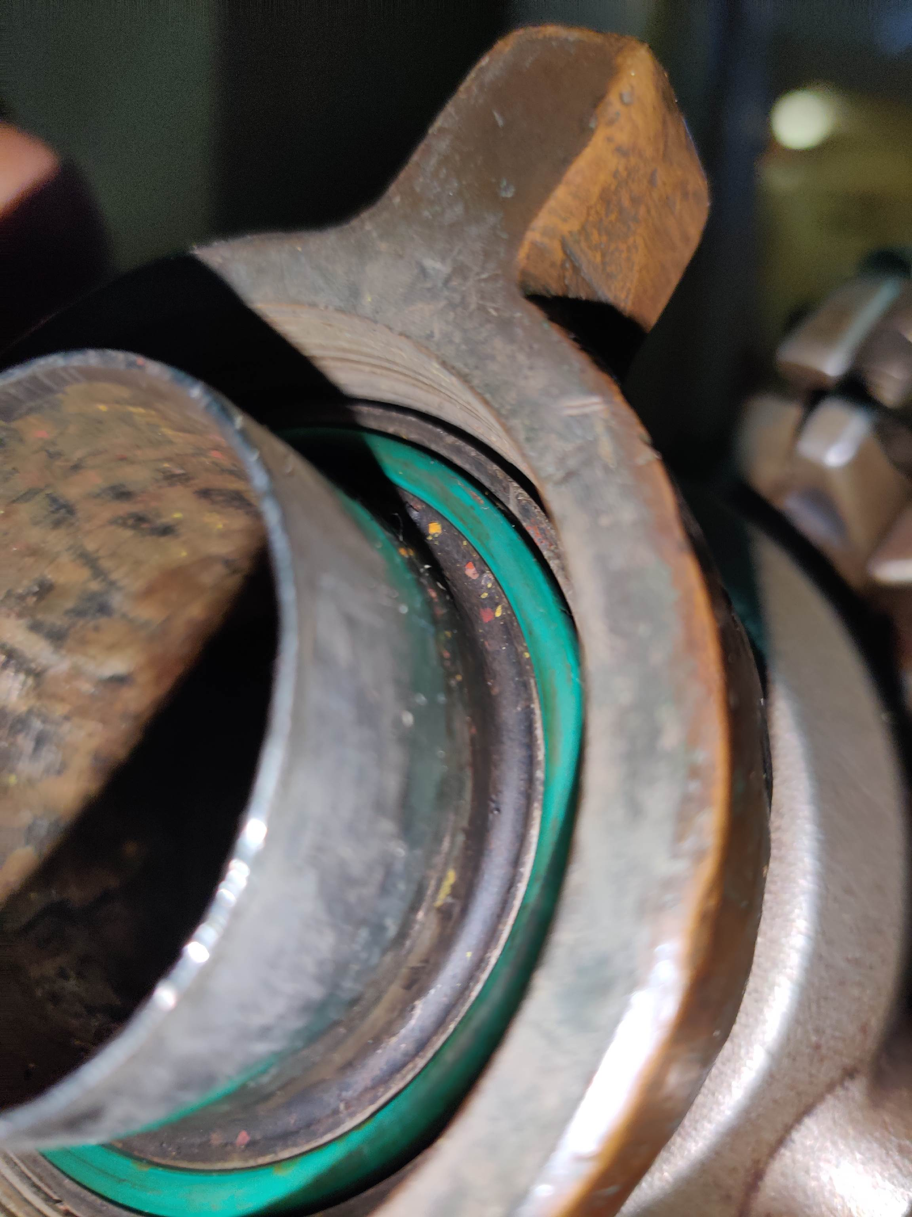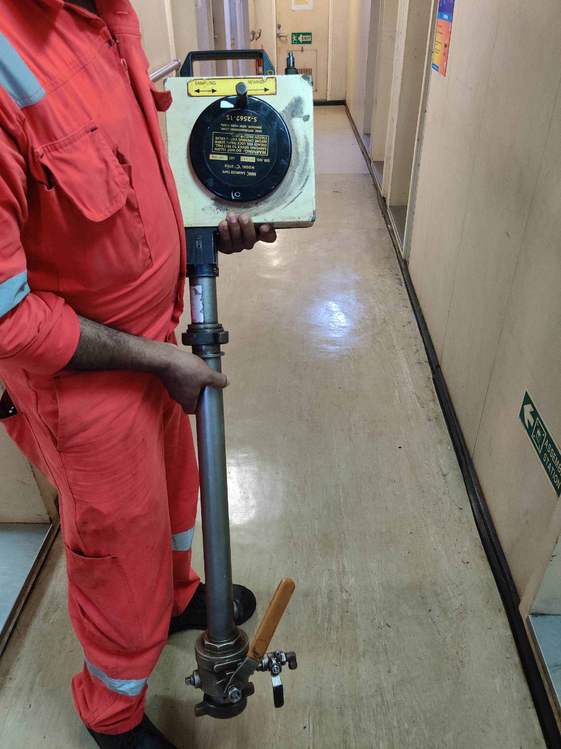
Bearing of lowring and heaving mechanism is damaged
Thread are worn out

